Tower Defense Game

Hours
It took around 25 hours to complete the project (spread over multiple weeks and usually while listening to ChinesePod.)

Math Principles
Some of the math principles utilized in this game are:
- Vector math (sine, cosine, angle, direction)
- Distance function (primarily for collision detection)
- Random seed (for map generation and wave generation)

Coding
The monsters in this game travel down a randomly generated path. To make the path, I used a simple random seed generator using the sine function. The sine function always generates a number from -1 to 1. If we multiply this by a high number (I used 100,000) and then take only the decimal part we are left with a number from 0 to 1 (not inclusive). If we multiply this number by 3 and then round down we get a string of seemingly random numbers from 0 to 2. This creates the appearance of randomness while allowing us to store an entire map with a single seed. It also allows the player to generate random maps as well.
To make the path I just generated a random number; if the number is 0, the path goes left; if the number is 1, the path goes right; and if the number is 2, the path goes down. If the direction is invalid (e.g. The path crossed over itself or tried to leave the screen) we generate a new number.
Once the path is made, the coordinates of the path are recorded so we can make sure the player doesn’t place towers on the path. The towers will fire projectiles at the furthest advanced enemy in their range.
There are three types of towers: Archer towers, Ballista towers and Rock towers. Ballista towers do heavy damage and reload slowly, Rock towers shoot light projectiles and reload quickly, and Archer towers are in between. Towers can be upgraded to Silver, Gold, and Legendary, but players can only choose two Silver upgrades and one Gold and Legendary upgrade.
There are a few different types of enemies as well. Regular enemies move at an average pace and have average health. Smaller enemies travel quicker but have less health. Armored enemies move slower but receive significantly less damage from non-armor piercing projectiles (the Cannonball, Ballista, and Laser are all armor piercing.) Some enemies spawn weaker enemies when they die, including the final boss.
At the end of the game (whether you win or lose) it will display the amount of damage dealt by each of your tower types (Archer, Ballista and Rock.) Below are some screenshots from the game.
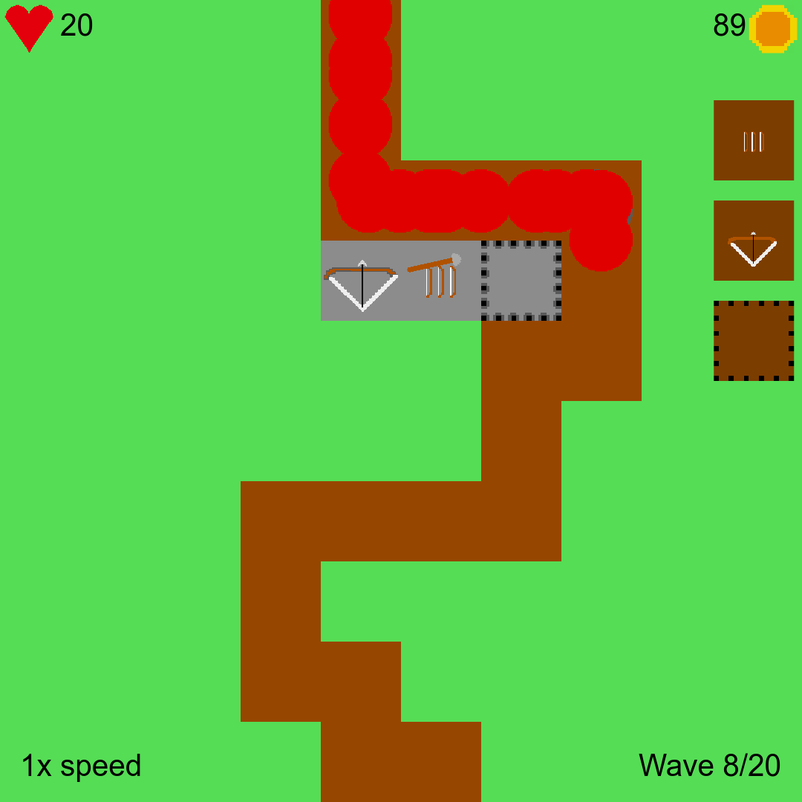The three types of towers: Ballista, Archer, and Rock (from left to right) | 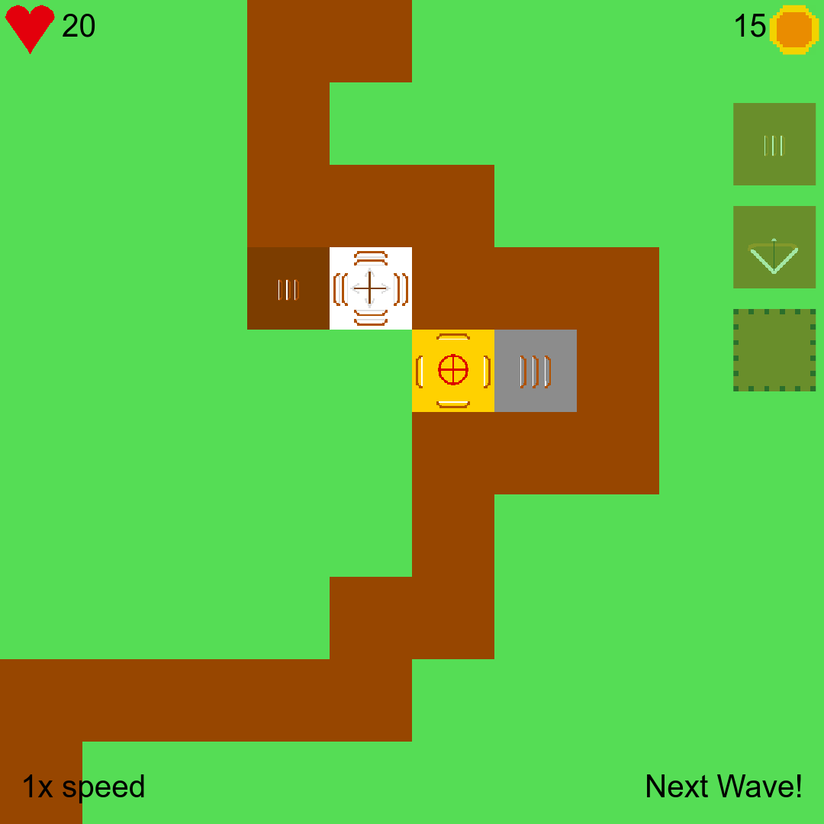Towers can be upgraded from Wood to Silver, Gold, and Legendary.
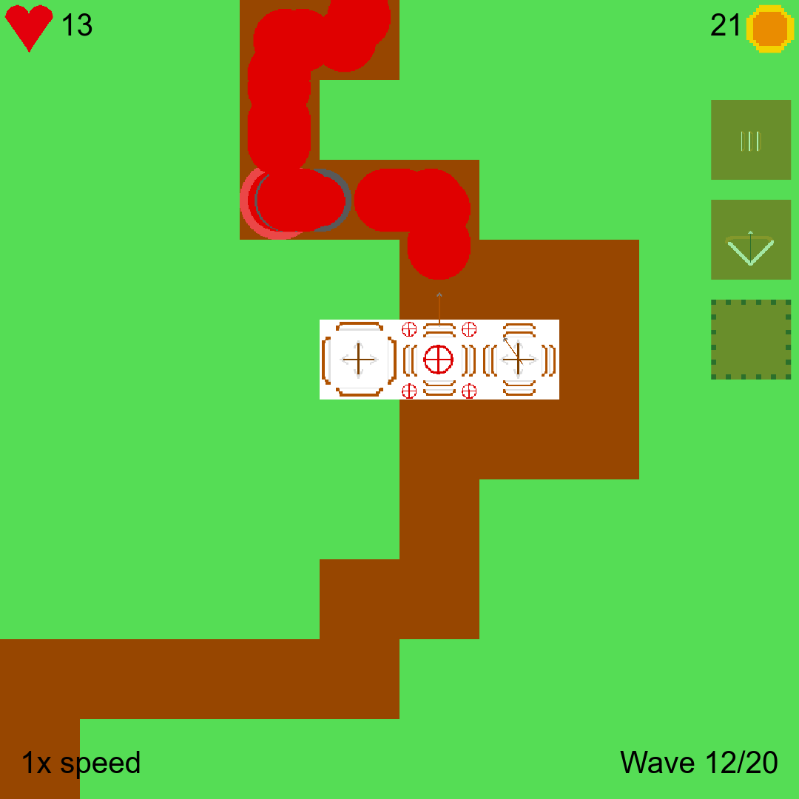There are three different types of legendary towers, all with different costumes. | 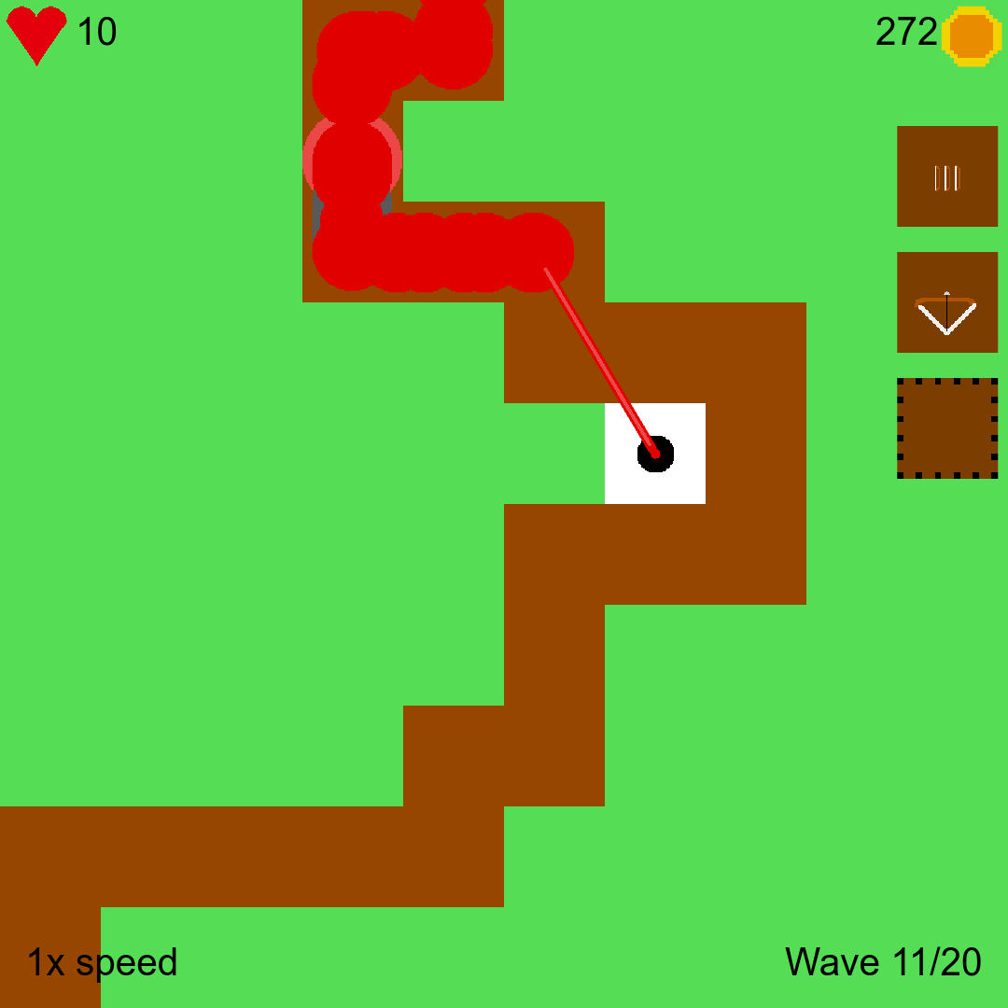The Laser tower deals damage directly to an enemy, rather than firing a projectile.
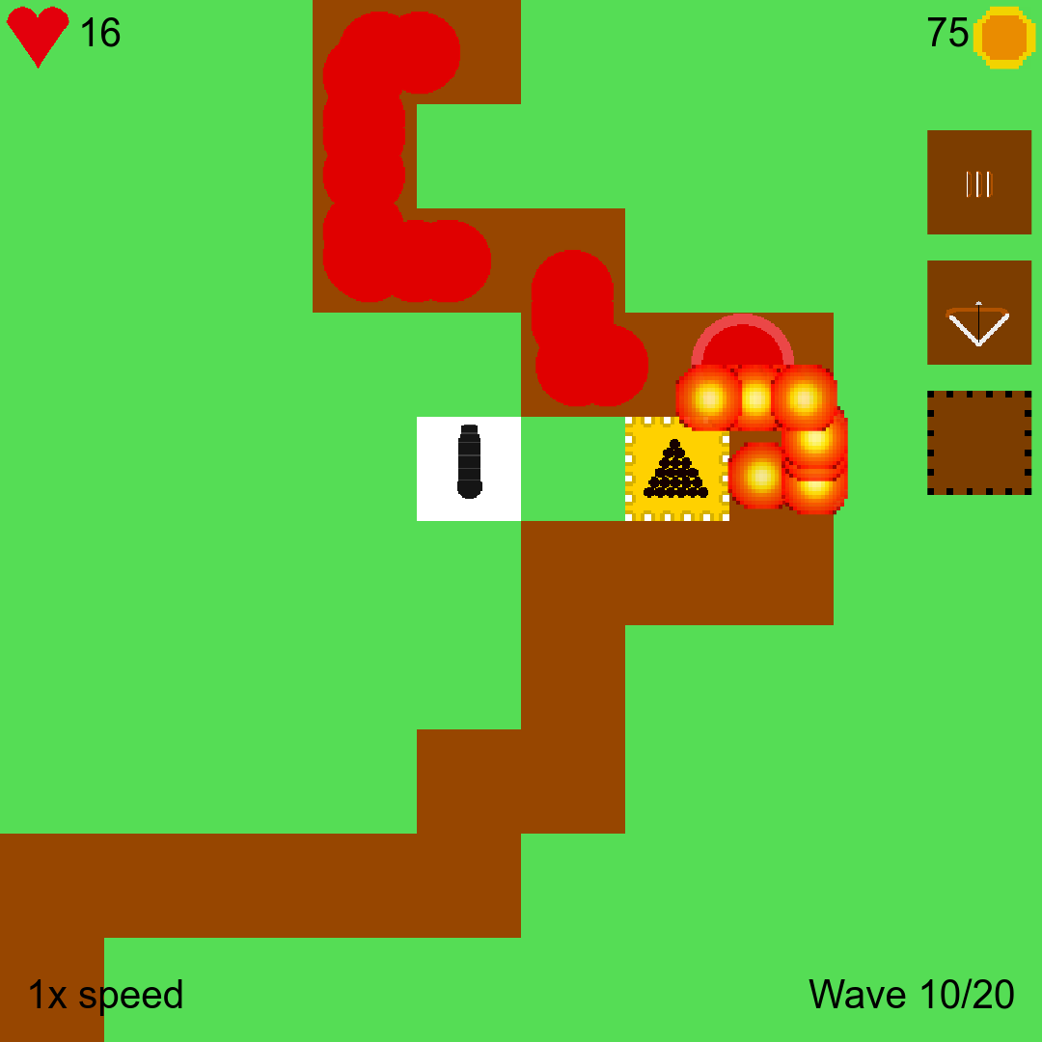Cannon towers shoot cannonballs, which explode and damage nearby enemies on impact. | 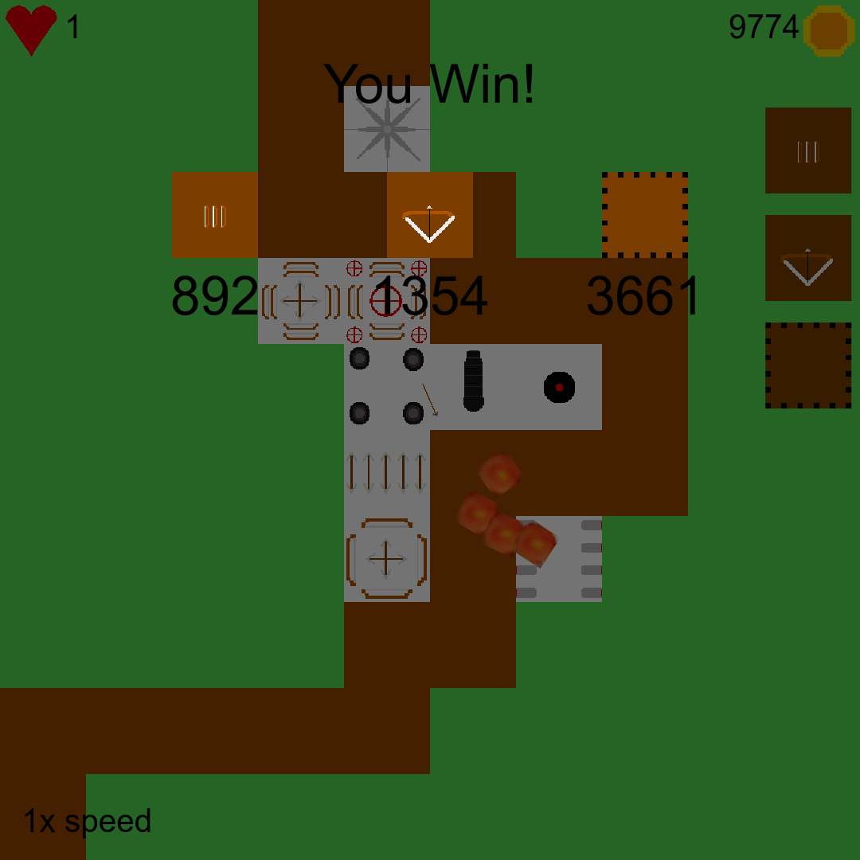Damage dealt by each tower type is shown when you win. In this game, the archer towers were placed in later waves..

